What is a CI/CD pipeline?
A CI/CD pipeline automates the process of software delivery. It builds code, runs tests, and helps you to safely deploy a new version of the software. CI/CD pipeline reduces manual errors, provides feedback to developers, and allows fast product iterations.
CI/CD pipeline introduces automation and continuous monitoring throughout the lifecycle of a software product. It involves from the integration and testing phase to delivery and deployment. These connected practices are referred as CI/CD pipeline.
What is continuous integration?
continuous integration (CI) focuses on the early stages of a software development pipeline where the code changes are built into artifacts that undergo automated tests. Multiple developers can work on the same codebase simultaneously and make frequent commits to the code repository. Build frequency can be daily or even several times per day at some points in the project's lifecycle. These small, frequent builds enable easy and low-risk experimentation, as well as the ability to easily roll back or abandon undesirable outcomes.
CI employs a variety of tools and automation techniques to create builds and shepherd them through initial testing, such as sniff or unit testing, along with more comprehensive integration and regression testing. CI is also noted for its rapid and detailed feedback, letting developers and project managers see the results of the team's work in a timely manner. The limited nature of each iteration means that changes are intentionally small, so bugs can be identified, located, reported and corrected with relative ease.
CI ends when a build successfully completes initial testing and is ready to move to more comprehensive testing, such as user acceptance testing. If the build fails testing, the branch can receive further attention -- such as bug fixes or more additions -- and the build/test cycle can repeat until a build is successful.
Version control is a critical part of the CI process. Each time a developer pulls code from a code repository, it creates a branch that represents a unique version of the current codebase. When a branch is successfully built and tested, the resulting branch is typically merged or integrated back into the main codebase, which is given a new version number. This lets other developers continue working on the codebase while preventing so many branches and changes that they can't be properly integrated.
Final preparations might include packaging the build into a deployable image, such as a Docker or Apache Mesos container or traditional virtual machine (VM) image, before making it available to dedicated testers and moving the build to staging or deployment.
What is continuous delivery?
Continuous delivery (CD) picks up where CI leaves off. It focuses on the later stages of a CI/CD pipeline, where a completed build is thoroughly tested, validated and delivered for deployment. Continuous delivery can -- but does not necessarily -- deploy a successfully tested and validated build.
In many cases, software delivery will result in a successful merge, where the successful branch is integrated back into the main codebase -- closing this abbreviated loop where developers can proceed with subsequent pulls to create new branches and updates.
In other cases, the successfully tested build can be packaged for deployment and delivered to a staging environment, such as a test server. Human managers can then decide whether to deploy the build, test the build in real-world conditions and report findings to developers, or forego deployment for the build in favor of continued development work.
CD likewise relies heavily on tools and automation to take a build through advanced testing, including functional, user acceptance, configuration and load testing. These validate that the build meets requirements and is ready for use in a production environment. Again, small incremental iterations ensure that any problems revealed in testing are identified and remediated quickly and less expensively than traditional software development approaches.
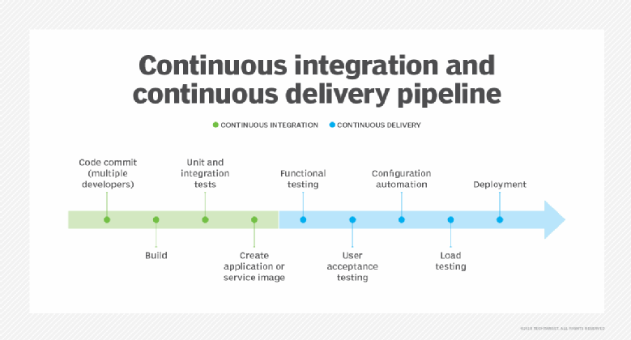
What is continuous deployment?
Continuous deployment (also CD) follows the same basic steps as continuous delivery. The principal difference between delivery and deployment is that continuous deployment deliberately and automatically deploys each validated build to production. By comparison, continuous delivery typically just stages the validated build for manual deployment or other human authorization.
Continuous deployment further accelerates the iterative software development process by eliminating the lag between build validation and deployment. However, such a paradigm could also let undetected flaws or vulnerabilities slip through testing and wind up in production. For many organizations, automated deployment presents too many potential risks to enterprise security and compliance. These teams prefer the continuous delivery paradigm in which humans review a validated build -- often with further testing and analysis -- before it is released. Organizations that adopt continuous deployment typically implement a robust rollback process to ensure that a previous stable version can be redeployed in the event of unexpected issues with the newly deployed version.
The common theme through these three continuous paradigms is a heavy reliance on automation and testing to drive the pipeline workflow. Ideally, a developer needs only "press the button" to whisk a new build from the code repository through testing and on to delivery or even deployment. This tantalizing proposition depends on the quality of the testing, the integrity of the automation behind it, and the careful attention of testers and software engineers.
Benefits and challenges of a CI/CD pipeline
The benefits of CI/CD pipelines include the following:
- Efficient software development. Smaller iterations -- keeping the changes to each branch small and light -- enable easier and more efficient testing. The limited scope of code in each new iteration, as well as the scope to test it, makes it easier to find and fix bugs. Features are more readily evaluated for usefulness and user acceptance, and less useful features are easily adjusted or even abandoned before further development is wasted.
- Competitive software products. Traditional software development approaches can take months or years to release, and formalized specifications and requirements aren't well suited to dynamically changing user needs and competitive environments. CI/CD development readily adapts to new and changing requirements, which enables developers to implement changes in subsequent iterations. Products developed with CI/CD can reach market faster and with more success.
- Freedom to fail. CI/CD's rapid cyclicality enables developers to experiment with innovative coding styles and creative or unorthodox algorithms with far less risk than traditional software development paradigms. If an experiment doesn't work out, it won't ever see production and can be undone in the next rapid iteration. The potential for competitive innovation is a powerful driver for organizations to use CI/CD.
- Better software maintenance. Bugs can take weeks or months to fix in traditional software development, but the constant flow of a CI/CD pipeline makes it easier to address and fix bugs faster and with better confidence. The product is more stable and reliable over time, leading to higher levels of software quality.
- Better operations support. Regular software releases keep operations teams in tune with the software's requirements and monitoring needs. Administrators are better able to deploy software updates and handle rollbacks with fewer deployment errors and needless troubleshooting. Similarly, IT automation technologies can help speed deployments while reducing setup or configuration errors.
- Availability of analytics. The many tools involved in CI/CD pipelines are typically well integrated and can collect myriad metrics and KPIs related to development work and quality outcomes. One common metric is development velocity, indicating the amount of code changed or added over time. Another common metric is defect volume, related to the number of problems or tickets generated over time or for a build. Analytics helps ensure CI/CD pipeline efficiency and can point to bottlenecks or problems that an organization can address.
Despite these compelling benefits, business leaders and development teams must consider some of the potential pitfalls of CI/CD pipelines:
- Dedication to automation. CI/CD relies on the consistency of an established tool set and strong automation framework to build, test and deploy each build. This demands a serious intellectual investment to implement and manage the automation, which can involve a steep learning curve and constant attention. Changes to the development process or tool set can profoundly impact the CI/CD pipeline, so CI/CD is often employed in mature and active development environments.
- Communication and collaboration. No amount of automation and tooling is a substitute for effective communication and collaboration among developers, operations teams, project managers and project stakeholders. These vital team interactions facilitate the rapid, efficient experimentation that makes CI/CD so powerful. Automation and tools are just the means to that end.
Elements of a good CD/CD pipeline
Here are some common characteristics of a good CI/CD process:
- Speed. A CI/CD pipeline can have numerous steps and parts, but a build should be able to move through the pipeline (integration, testing, delivery and even deployment) in short order -- just minutes to complete an integration and a few hours for testing cycles to finish. If it takes days to move a build through the pipeline, a great deal of valuable time is being wasted, and the process needs fine-tuning.
- Consistency. The processes and components used in one place or cycle are exactly the same in all places and cycles. For example, if a build results in a Docker container, that container is the object that's tested and moved through the pipeline to delivery or deployment. Developers can write scripts and create automation processes with confidence that such efforts will be successful and deliver the desired results every time. Processes that introduce variations or manual steps slow the pipeline and invite errors and inefficiency.
- Tight version control. Well-documented repositories or components and builds enable comprehensive branching and merging as well as rapid restoration of previous builds when new builds or deployments go awry. Good version control facilitates fast, accurate and confident rollbacks to the previous working version whenever the need arises.
- Automation. Extensive automation moves new code through integration, testing and delivery or deployment with little, if any, manual interaction. Ideally, a human does little more than develop and commit code, then wait for an approved pull request and approval before a deployment, if needed. A pipeline that depends on manual steps and processes is slow and prone to errors.
- Integrated feedback loops. A CI/CD pipeline is a loop that yields countless iterative steps to a completed project, and each phase also offers a loop back to the beginning. A problem with the source code won't generate a build. A problem with the build won't move into testing. A problem in testing or after deployment will demand source fixes. The sooner a problem is identified, the faster, easier and cheaper it is to fix, keeping the overall pipeline in motion. Instrumentation can often be added to collect important metrics and provide comprehensive reporting for added feedback, which can help optimize the CI/CD process.
- Solid tool interoperability. A CI/CD pipeline can involve many tools, and each tool across the pipeline should integrate well -- or support some level of interoperability so the output product of one tool can easily feed the input of the next tool in the pipeline. Without good integration or interoperability, the pipeline might require manual conversions or other human intervention that can lead to errors and inefficiency. A central part of CI/CD tool selection is the consideration of interoperability and suitability to task.

- Stages of a CI/CD pipeline
- A CI/CD pipeline is a runnable specification of the steps that any developer should perform to deliver a new version of any software. Failure in each and every stage triggers a notification via email, Slack, or other communication platforms. It enables responsible developers to know about the important issues.
- Here are the important Stages of CI/CD pipeline:
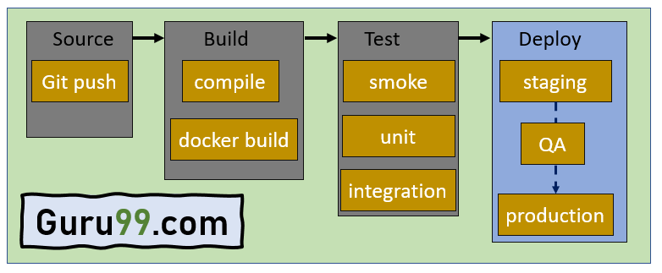

Source Stage
In the source stage, CI/CD pipeline is triggered by a code repository. Any change in the program triggers a notification to the CI/CD tool that runs an equivalent pipeline. Other common triggers include user-initiated workflows, automated schedules, and the results of other pipelines.
Build Stage
This is the second stage of the CI/CD Pipeline in which you merge the source code and its dependencies. It is done mainly to build a runnable instance of software that you can potentially ship to the end-user.
Programs that are written in languages like C++, Java, C, or Go language should be compiled. On the other hand, JavaScript, Python, and Ruby programs can work without the build stage.
Failure to pass the build stage means there is a fundamental project misconfiguration, so it is better that you address such issue immediately.
Test Stage
Test Stage includes the execution of automated tests to validate the correctness of code and the behaviour of the software. This stage prevents easily reproducible bugs from reaching the clients. It is the responsibility of developers to write automated tests.
Deploy Stage
This is the last stage where your product goes live. Once the build has successfully passed through all the required test scenarios, it is ready to deploy to live server.

